**React Redux Tutorial**

React is one of the most popular JavaScript libraries which is used for front-end development. It has made our application development easier and faster by providing the component based approach.

React not the complete framework but just the view part of the MVC (Model-View-Controller) framework. So, how do you keep track of the data and handle the events in the applications developed using React? Well, this is where Redux comes as a savior and handles the data flow of the application from the backend.

Redux with React applications.

* [Why Redux With React?](https://www.edureka.co/blog/react-redux-tutorial/#1)
* [What Is Redux?](https://www.edureka.co/blog/react-redux-tutorial/#2)
* [Advantages Of Redux](https://www.edureka.co/blog/react-redux-tutorial/#3)
* [Components Of Redux](https://www.edureka.co/blog/react-redux-tutorial/#4)
* [React with Redux](https://www.edureka.co/blog/react-redux-tutorial/#5)

**Why Redux With React? – React Redux Tutorial**

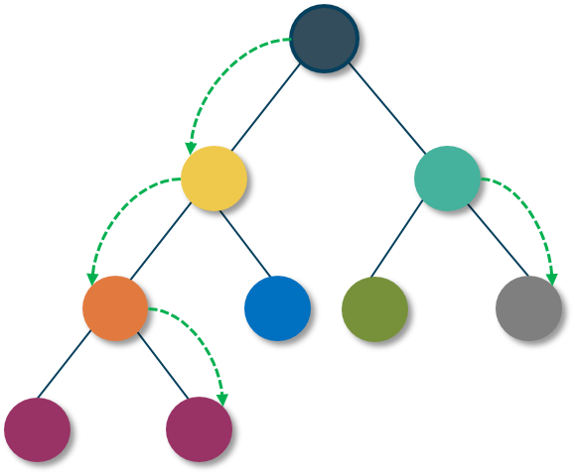

React follows the component based approach, where the data flows through the components. In-fact, the data in React always flows from parent to child components which makes it *unidirectional*. This surely keeps our data organized and helps us in controlling the application better. Because of this, the application’s state is contained in specific stores and as a result, the rest of the components remain loosely coupled. This makes our application more flexible leading to increased efficiency. That’s why the communication from a parent component to a child component is convenient.

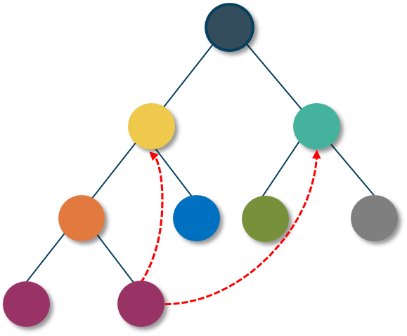

But what happens when we try to communicate from a non-parent component?

A child component can never pass data back up to the parent component. React does not provide any way for direct component-to-component communication. Even though React has features to support this approach, it is considered to be a poor practice. It is prone to errors and leads to spaghetti code. So, how can two non-parent components pass data to each other?

This is where the React fails to provide a solution and Redux comes into the picture.

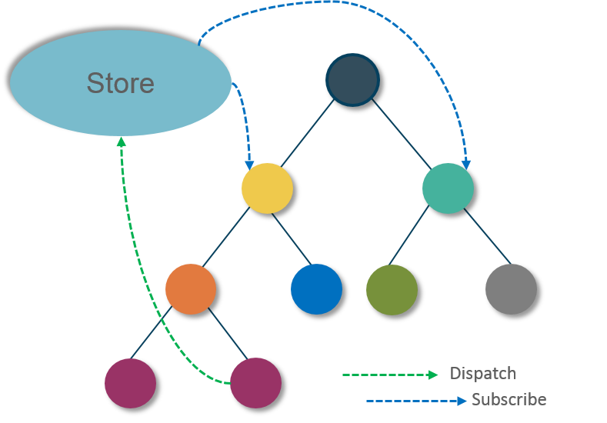Redux provides a “**store**” as a solution to this problem. A store is a place where you can store all your application state together. Now the components can “*dispatch*” state changes to the store and not directly to the other components. Then the components that need the updates about the state changes can “*subscribe*” to the store.

Thus, with Redux, it becomes clear where the components get their state from as well as where should they send their states to. Now the component initiating the change does not have to worry about the list of components needing the state change and can simply dispatch the change to the store. This is how Redux makes the *data flow* easier.

**What Is Redux? – React Redux Tutorial**

Just like React, Redux is also a library which is used widely for front-end development. It is basically a tool for managing both data-state and UI-state in JavaScript applications. Redux separates the application data and business logic into its own container in order to let React manage just the view. Rather than a traditional library or a framework, it’s an application data-flow architecture. It is most compatible with Single Page Applications (SPAs) where the management of the states over time can get complex.

Redux was created by *Dan Abramov* and *Andrew Clark* around June 2015. It was inspired by Facebook’s Flux and influenced by functional programming language *Elm*. Redux got popular very quickly because of its simplicity, small size (only 2 KB) and great documentation.

**Principles Of Redux**

Redux follows three fundamental principles:

1. ***Single source of truth:***The state of the entire application is stored in an object/ state tree within a single store. The single state tree makes it easier to keep track of the changes over time and debug or inspect the application. For a faster development cycle, it helps to persist the application’s state in development.
2. ***State is read-only:***The only way to change the state is to trigger an action. An action is a plain JS object describing the change. Just like the state is the minimal representation of data, the action is the minimal representation of the change to that data. An action must have a type property (conventionally a String constant). All the changes are centralized and occur one by one in a strict order.
3. ***Changes are made with pure functions:*** In order to specify how the state tree is transformed by actions, you need pure functions. Pure functions are those whose return values depend solely on the values of their arguments. Reducers are just pure functions that take the previous state and an action and return the next state. You can have a single reducer in your application and as it grows, you can split it off into smaller reducers. These smaller reducers will then manage specific parts of the state tree.

**Advantages Of Redux – React Redux Tutorial**

Following are some of the major advantages of Redux:

* **Predictability of outcome –**Since there is always one source of truth, i.e. the store, there is no confusion about how to sync the current state with actions and other parts of the application.
* **Maintainability –**The code becomes easier to maintain with a predictable outcome and strict structure.
* **Server side rendering –** You just need to pass the store that is created on the server, to the client side. This is very useful for initial render and provides a better user experience as it optimizes the application performance.
* **Developer tools –**From actions to state changes, developers can track everything going on in the application in real time.
* **Community and ecosystem –**Redux has a huge community behind it which makes it even more captivating to use. A large community of talented individuals contribute to the betterment of the library and develop various applications with it.
* **Ease of testing –**Redux code are mostly functions which are small, pure and isolated. This makes the code testable and independent.
* **Organization –**Redux is very precise about how the code should be organized, this makes the code more consistent and easier when a team works with it.

**Components Of Redux – React Redux Tutorial**

Redux has four components.

1. Action
2. Reducer
3. Store
4. View

Let us discuss them in detail:

* **Action –**The only way to change state content is by emitting an action. Actions are the plain JavaScript objects which are the main source of information used to send data (user interactions, internal events such as API calls, and form submissions) from the application to the store. The store receives information only from the actions. You have to send the actions to the store using **store.dispatch()**.  
  Internal actions are simple JavaScript objects that have a**type** property (usually String constant), describing the type of action and the entire information being sent to the store.

|  |  |
| --- | --- |
| 1  2  3  4 | {      type: ADD_TODO,      text  } |

* Actions are created using action creators which are the normal functions that return actions.

|  |  |
| --- | --- |
| 1  2  3  4  5  6 | function addTodo(text) {      return {          type: ADD_TODO,          text      }  } |

* To call actions anywhere in the app, use **dispatch()**method:

|  |  |
| --- | --- |
| 1 | dispatch(addTodo(text)); |

* **Reducer –**Actions describe the fact that *something happened*, but don’t specify how the application’s state changes in response. This is the job of reducers. It is based on the array reduce method, where it accepts a callback (reducer) and lets you get a single value out of multiple values, sums of integers, or an accumulation of streams of values. In Redux, reducers are functions (pure) that take the current state of the application and an action and then return a new state. Understanding how reducers work is important because they perform most of the work.

|  |  |
| --- | --- |
| 1  2  3  4  5  6  7  8  9  10  11  12  13  14  15 | function reducer(state = initialState, action) {      switch (action.type) {          case ADD_TODO:              return Object.assign({}, state,                  { todos: [ ...state.todos,                      {                          text: action.text,                          completed: false                      }                      ]                  })          default:              return state      }  } |

* **Store –**A store is a JavaScript object which can hold the application’s state and provide a few helper methods to access the state, dispatch actions and register listeners. The entire state/ object tree of an application is saved in a single store. As a result of this, Redux is very simple and predictable. We can pass middleware to the store to handle processing of data as well as to keep a log of various actions that change the state of stores. All the actions return a new state via reducers.

|  |  |
| --- | --- |
| 1  2  3  4 | import { createStore } from 'redux'  import todoApp from './reducers'    let store = createStore(reducer); |

* **View –**Smart and dumb components together build up the view. The only purpose of the view is to display the date passed down by the store. The smart components are in charge of the actions. The dumb components underneath the smart components notify them in case they need to trigger the action. The smart components, in turn, pass down the props which the dumb components treat as callback actions.

Following is a diagram which shows how the data actually flows through all the above-described components in Redux.

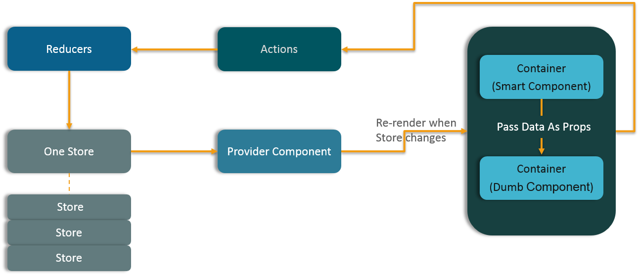

**React With Redux  – React Redux Tutorial**

Now that you are familiar with Redux and its components, let’s now see how you can integrate it with a React application.

=====================================================

>**npx create-react-app reduxapp1**

Used to create react app

* + cd reduxapp1
  + **npm start** and open browser at <http://localhost:3000>
  + open reduxapp1 folder in IDE and edit App.js file

in Appjs file add the below content:

================================================================

import React, { Component } from 'react';

import './App.css';

class App extends Component {

addTodo(event) {

event.preventDefault();

let name=this.refs.name.value;

let done=this.refs.done.value;

let todo ={

name,done

};

let todos =this.state.todos;

todos.push(todo);

this.setState({todos:todos})

}

constructor() {

super();

this.addTodo=this.addTodo.bind(this);

this.state= {

todos:[],

title: 'Ract simple todo app'

}

}

render() {

let title=this.state.title;

let todos=this.state.todos;

return (

<div className="App">

<h1> Welcome to CTS </h1>

<form>

<input type="text" ref="name"/>

<input type="text" ref="done"/>

<button onClick={this.addTodo}>Add todo </button>

</form>

<pre>

{JSON.stringify(todos)}

</pre>

</div>

);

}

}

export default App;

======================================================================

Add cunter:

import React, { Component } from 'react';

import './App.css';

class App extends Component {

addTodo(event) {

event.preventDefault();

let name=this.refs.name.value;

let done=this.refs.done.value;

let counter=this.refs.counter;

let todo ={

name,done,counter

};

counter+=1;

let todos =this.state.todos;

todos.push(todo);

this.setState({todos:todos,counter:counter});

this.refs.todoForm.reset();

}

constructor() {

super();

this.addTodo=this.addTodo.bind(this);

this.state= {

todos:[],

title: 'Ract simple todo app',

counter:0

}

}

render() {

let title=this.state.title;

let todos=this.state.todos;

return (

<div className="App">

<h1> Welcome to CTS </h1>

<form ref="todoForm">

<input type="text" ref="name"/>

<input type="text" ref="done"/>

<button onClick={this.addTodo}>Add todo </button>

</form>

<ul>

{todos.map((todo => <li key={todo.counter}>{todo.name}</li> ))}

</ul>

<pre>

{JSON.stringify(todos)}

</pre>

</div>

);

}

}

export default App;

======================================================================

**>npm install redux --save**

**>npx create-eract-app reduxapp2**

**Edit below files**

**App.js**

**ReduxDemo.js**

**Step1-> embedding ReduxDemo component into App**

import React , {Component } from 'react';

import { createStore} from 'redux'

class ReduxDemo extends Component {

render() {

return (

<div> <h1> Welcome to REdux </h1>

</div>

);

}

}

export default ReduxDemo;

**=================================**

import React, { Component } from 'react';

import logo from './logo.svg';

import './App.css';

import ReduxDemo from './ReduxDemo';

class App extends Component {

render() {

return (

<div className="App">

<header className="App-header">

<img src={logo} className="App-logo" alt="logo" />

<h1 className="App-title">Welcome to React</h1>

</header>

<p className="App-intro">

To get started, edit <code>src/App.js</code> and save to reload.

</p>

<ReduxDemo/>

</div>

);

}

}

export default App;

**===========================================**

**ReduxDemo with redux features:**

import React , {Component } from 'react';

import { createStore} from 'redux'

class ReduxDemo extends Component {

render() {

//step2 : REducer : state n action

const reducer = function (state,action) {

if(action.type==='ATTACK'){

return action.payload

}

if(action.type==='GREENATTACK'){

return action.payload

}

return state;

}

//step1 Store : reducer n state

const store=createStore(reducer,"Peace");

//step 3 :subscribe

store.subscribe(()=> {

console.log("Store is now ",store.getState());

})

//step 4 : dispatch

store.dispatch({type:"ATTACK",payload: "Iron Man"})

store.dispatch({type:"GREENATTACK",payload: "HULK"})

return (

<div> <h1> Welcome to Redux </h1>

</div>

);

}

}

export default ReduxDemo;

**STEP 1:**You need to setup the basic react, webpack, babel setup. Following are the dependencies we are using in this application.

|  |  |
| --- | --- |
| 1  2  3  4  5  6  7  8  9  10  11  12  13  14  15  16  17  18  19  20  21  22  23  24  25  26  27 | "dependencies": {    "babel-core": "^6.10.4",    "babel-loader": "^6.2.4",    "babel-polyfill": "^6.9.1",    "babel-preset-es2015": "^6.9.0",    "babel-preset-react": "^6.11.1",    "babel-register": "^6.9.0",    "cross-env": "^1.0.8",    "css-loader": "^0.23.1",    "expect": "^1.20.1",    "node-libs-browser": "^1.0.0",    "node-sass": "^3.8.0",    "react": "^15.1.0",    "react-addons-test-utils": "^15.1.0",    "react-dom": "^15.1.0",    "react-redux": "^4.4.5",    "redux": "^3.5.2",    "redux-logger": "^2.6.1",    "redux-promise": "^0.5.3",    "redux-thunk": "^2.1.0",    "sass-loader": "^4.0.0",    "style-loader": "^0.13.1",    "webpack": "^1.13.1",    "webpack-dev-middleware": "^1.6.1",    "webpack-dev-server": "^1.14.1",    "webpack-hot-middleware": "^2.11.0"  }, |

**STEP 2:** Once you are done with installing the dependencies, then create**components**folder in**src**folder. Within that create **App.js** file.

|  |  |
| --- | --- |
| 1  2  3  4  5  6  7  8  9  10  11  12  13  14  15  16 | import React from 'react';  import UserList from '../containers/user-list';  import UserDetails from '../containers/user-detail';  require('../../scss/style.scss');    const App = () => (      <div>          <h2>User List</h2>          <UserList />          <hr />          <h2>User Details</h2>          <UserDetails />      </div>  );    export default App; |

**STEP 3:**Next create a new **actions** folder and create **index.js** in it.

|  |  |
| --- | --- |
| 1  2  3  4  5  6  7 | export const selectUser = (user) => {      console.log("You clicked on user: ", user.first);      return {          type: 'USER_SELECTED',          payload: user      }  }; |

**STEP 3:** Now create**user-details.js**in a new folder called **containers.**

|  |  |
| --- | --- |
| 1  2  3  4  5  6  7  8  9  10  11  12  13  14  15  16  17  18  19  20  21  22  23  24  25  26 | import React, {Component} from 'react';  import {connect} from 'react-redux';    class UserDetail extends Component {      render() {          if (!this.props.user) {              return (<div>Select a user...</div>);          }          return (              <div>                  <img height="150" width="150" src={this.props.user.thumbnail} />                  <h2>{this.props.user.first} {this.props.user.last}</h2>                  <h3>Age: {this.props.user.age}</h3>                  <h3>Description: {this.props.user.description}</h3>              </div>          );      }  }    function mapStateToProps(state) {      return {          user: state.activeUser      };  }    export default connect(mapStateToProps)(UserDetail); |

**STEP 4:** Inside the same folder create **user-list.js** file.

|  |  |
| --- | --- |
| 1  2  3  4  5  6  7  8  9  10  11  12  13  14  15  16  17  18  19  20  21  22  23  24  25  26  27  28  29  30  31  32  33 | import React, {Component} from 'react';  import {bindActionCreators} from 'redux';  import {connect} from 'react-redux';  import {selectUser} from '../actions/index'  class UserList extends Component {      renderList() {          return this.props.users.map((user) => {              return (                  <li key={user.id}                      onClick={() => this.props.selectUser(user)}                  >                      {user.first} {user.last}                  </li>              );          });      }      render() {          return (              <ul>                  {this.renderList()}              </ul>          );      }  }  function mapStateToProps(state) {      return {          users: state.users      };  }  function matchDispatchToProps(dispatch){      return bindActionCreators({selectUser: selectUser}, dispatch);  }  export default connect(mapStateToProps, matchDispatchToProps)(UserList); |

**STEP 5:** Now create **reducers** folder and create **index.js** within it.

|  |  |
| --- | --- |
| 1  2  3  4  5  6  7  8  9 | import {combineReducers} from 'redux';  import UserReducer from './reducer-users';  import ActiveUserReducer from './reducer-active-user';    const allReducers = combineReducers({      users: UserReducer,      activeUser: ActiveUserReducer  });  export default allReducers |

**STEP 6:** Within the same**reducers** folder, create **reducer-users.js**file.

|  |  |
| --- | --- |
| 1  2  3  4  5  6  7  8  9  10  11  12  13  14  15  16  17  18  19  20  21  22  23  24  25  26  27  28 | export default function () {      return [          {              id: 1,              first: "Maxx",              last: "Flinn",              age: 17,              description: "Loves basketball",              thumbnail: "<https://goo.gl/1KNpiy>"          },          {              id: 2,              first: "Allen",              last: "Matt",              age: 25,              description: "Food Junky.",              thumbnail: "<https://goo.gl/rNLgwv>"          },          {              id: 3,              first: "Kris",              last: "Chen",              age: 23,              description: "Music Lover.",              thumbnail: "<https://goo.gl/EVbPHb>"          }      ]  } |

**STEP 7:**Now within **reducers** folder create a **reducer-active-user.js** file.

|  |  |
| --- | --- |
| 1  2  3  4  5  6  7  8 | export default function (state = null, action) {      switch (action.type) {          case 'USER_SELECTED':              return action.payload;              break;      }      return state;  } |

**STEP 8:**Now you need to create **index.js** in the **root** folder.

|  |  |
| --- | --- |
| 1  2  3  4  5  6  7  8  9  10  11  12  13  14  15  16  17  18  19  20  21  22  23 | import 'babel-polyfill';  import React from 'react';  import ReactDOM from "react-dom";  import {Provider} from 'react-redux';  import {createStore, applyMiddleware} from 'redux';  import thunk from 'redux-thunk';  import promise from 'redux-promise';  import createLogger from 'redux-logger';  import allReducers from './reducers';  import App from './components/App';    const logger = createLogger();  const store = createStore(      allReducers,      applyMiddleware(thunk, promise, logger)  );    ReactDOM.render(      <Provider store={store}>          <App />      </Provider>,      document.getElementById('root')  ); |

**STEP 9:** Now that you are done writing the codes, launch your application at ***localhost:3000***